## Steps to Create AWS Redshift database.

1. Create a IAM ROLE with following policies as shown below

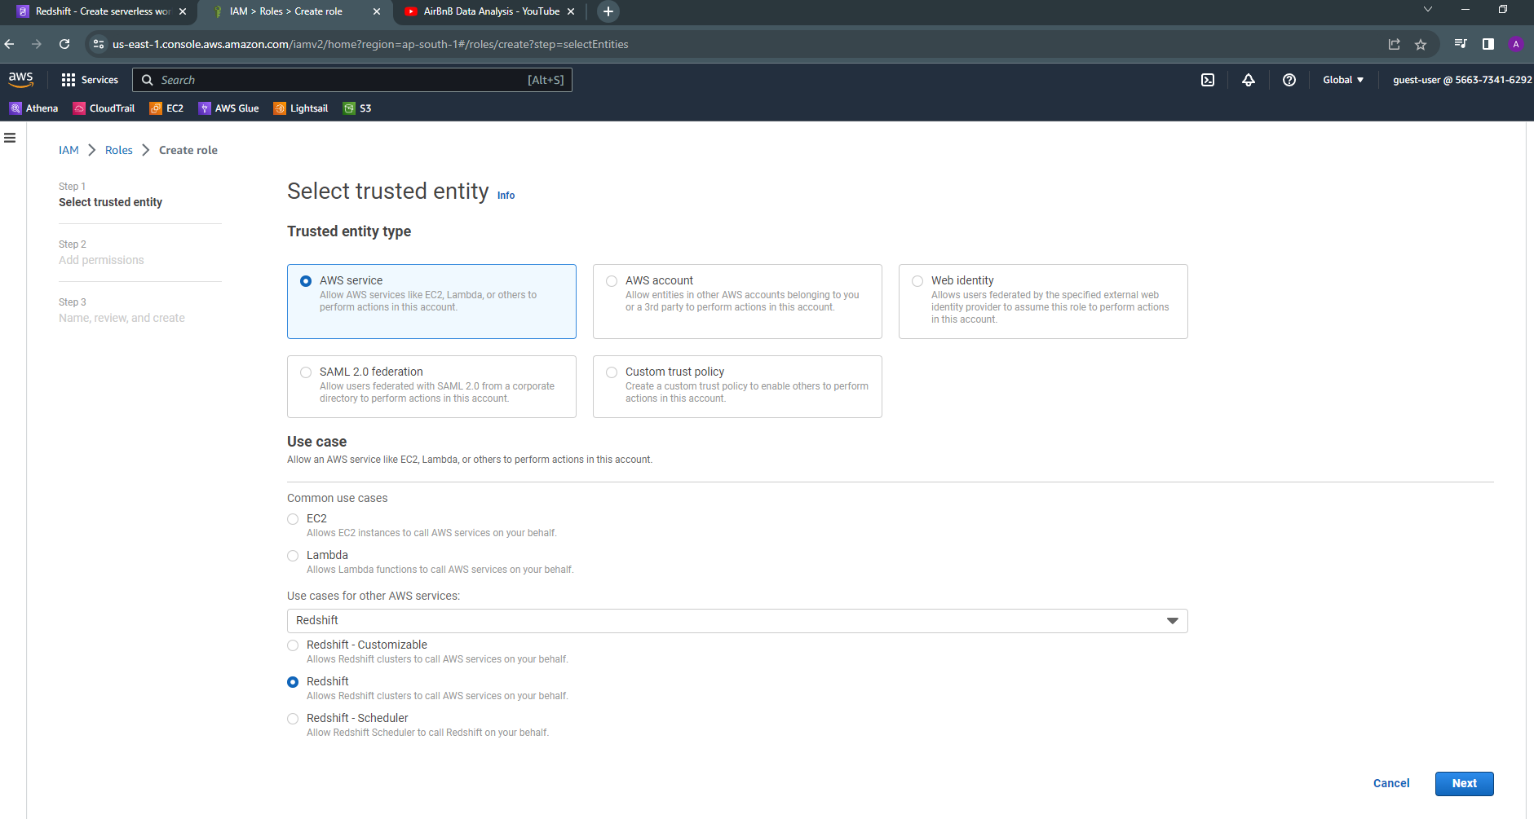

**POLICY WOULD BE**

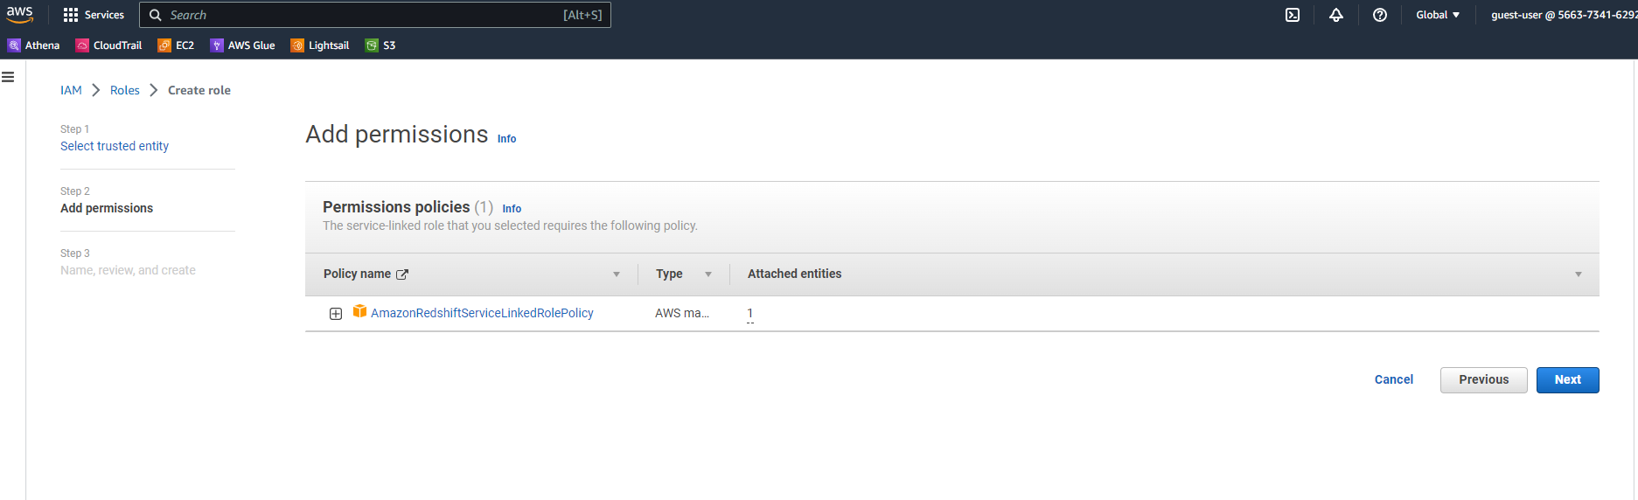

1. You can also select the same default IAM setting at time of creation as shown below

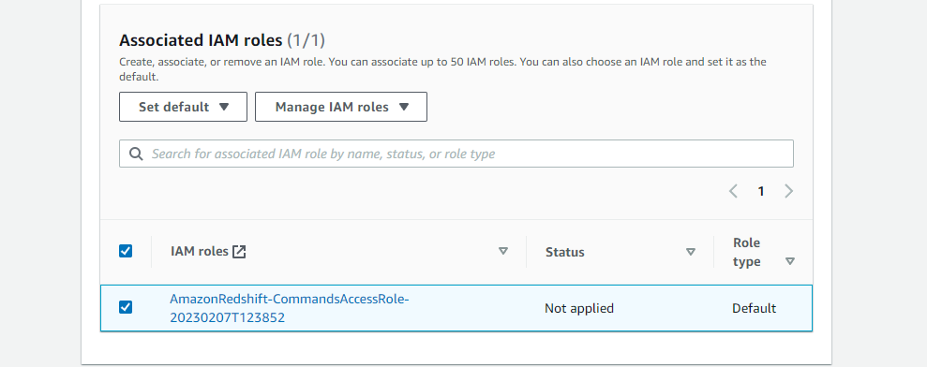

1. **And click Create.**
2. **After the cluster is created click on QUERY DATA and load the final data from the S3 bucket to your redshift cluster**

**As shown**

